1. **Question :-**
2. **Create an ec2 instance and attach the volume..**
3. **Add software configuration in ec2 instance and add files inside the volume…**
4. **Delete the PEM file…**
5. **Now Retrive the ec2 instance and volume…**
6. **Steps for above questions ….**
7. **Created new instance with the name DEMO-VOLUME…For this instance volume attached…**
8. **That instance has connect on CLI Through ssh-key….**

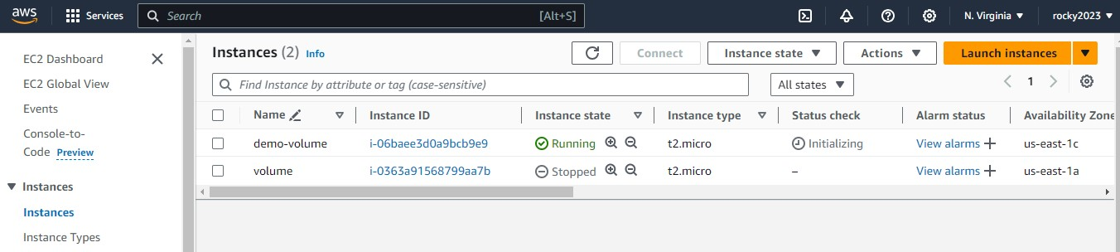

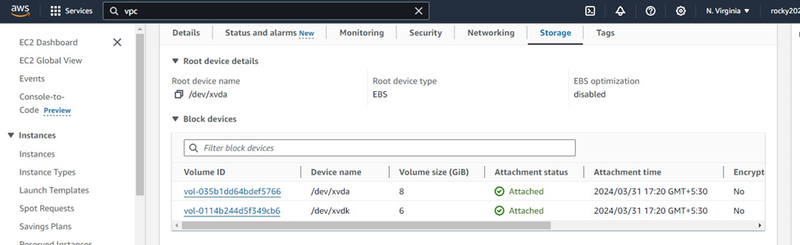

1. **After connecting Had installed software configurations lik, JAVA, MAVEN, GIT….**
2. **Below imagesA and B as shown that installed configurations versions..**

**Image A**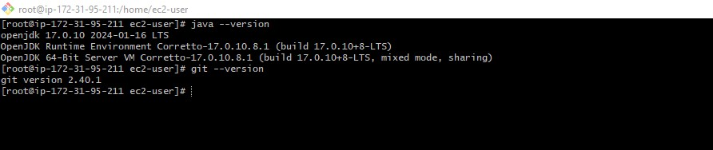

**Image B**

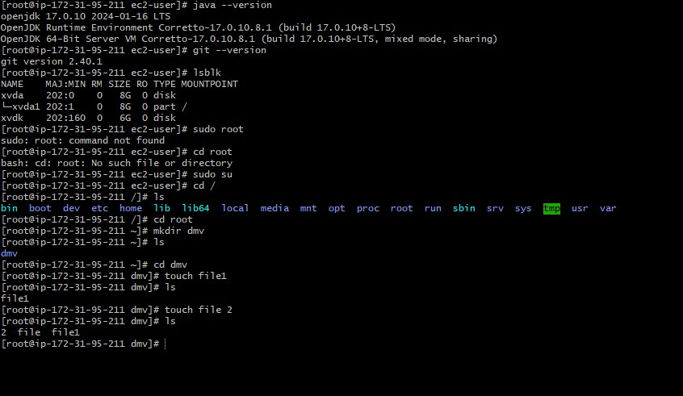

1. **Here the step for mounting the volume with specific commands as shown in below..**

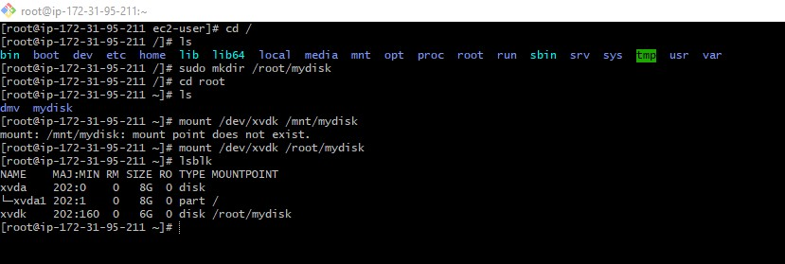

1. **When running instance stopped if again I try to connect it throughs error that below image shown…**

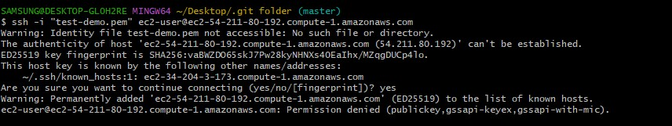

1. **Steps for creating AMI templates From existing instance we have created the AMI template…**
2. **Select the instance and go for actions ….their select image and templates…**
3. **Next select create image..**

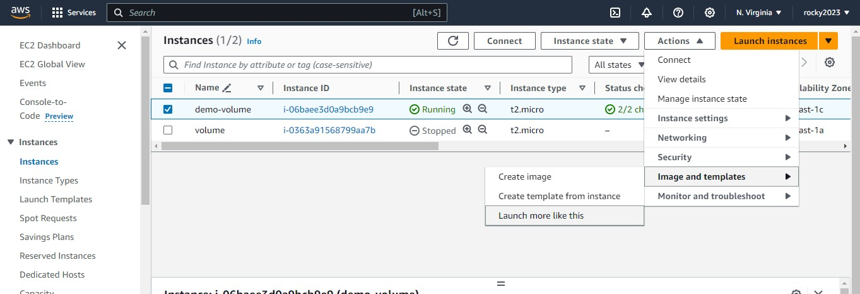

1. **Below image shown that creating AMI image …**

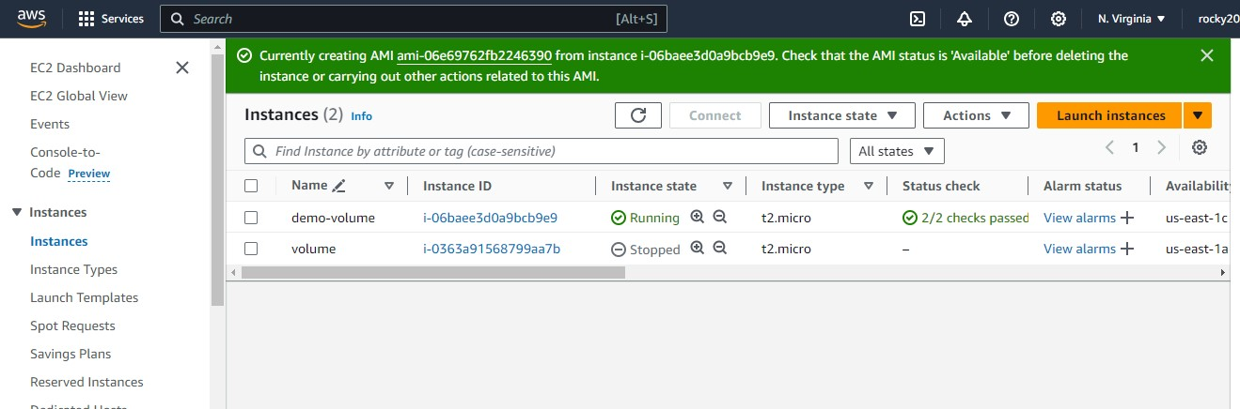

1. **Here next after that creating AMI image …I will terminating the existing instance as shown in below image…**

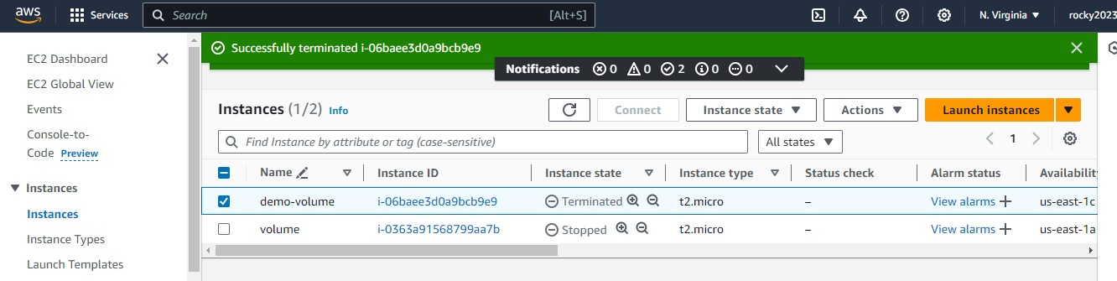

1. **Launch new instance by selecting the option MY AMIs its in below image..**

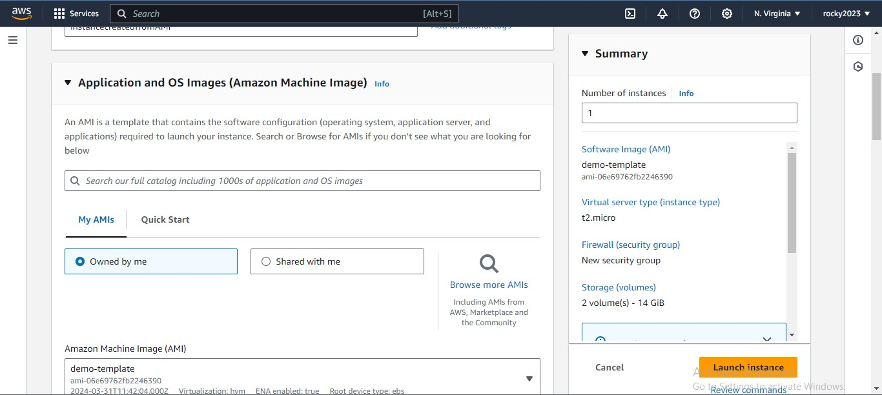

**10) Succesfully initiated new instance…Below both images shown …..in the name instancescreated…**

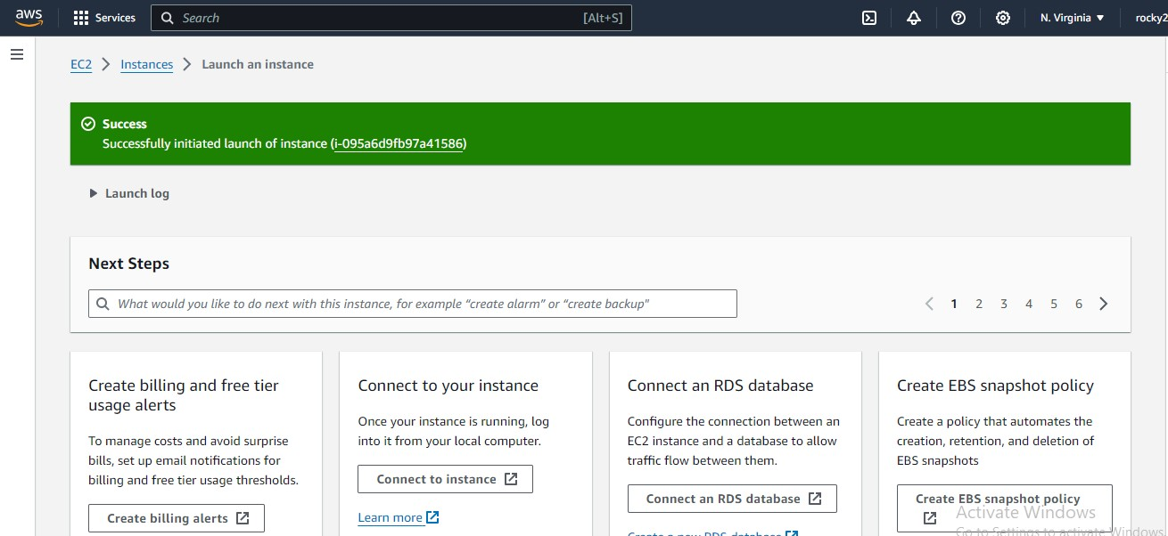

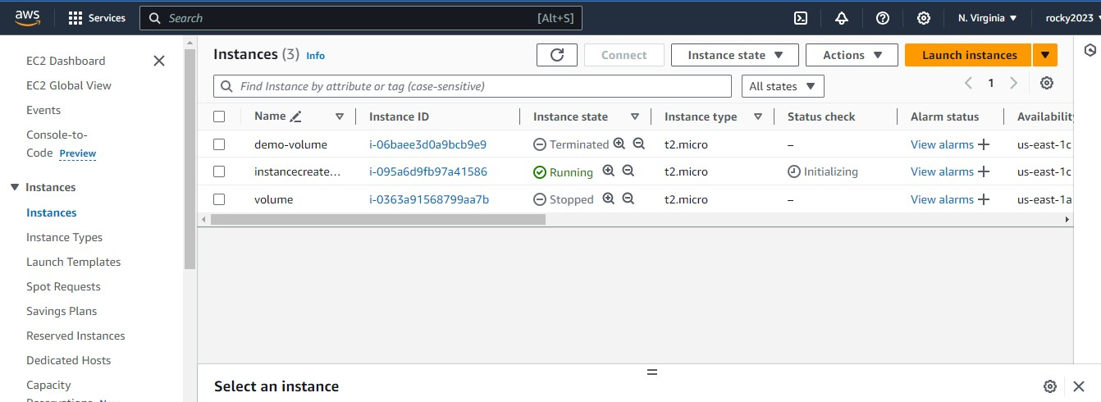

**11 ) Newly created instance had connected on CLI through SSH key…**

1. **After successfully connecting had to check the software configuration that we created at that old instance…**
2. **Will check with particular commands.. as shown in below images with directory and files what we created…**

